📊 Customer Purchase Behavior Analysis
- Executive Summary
This project analyzes customer shopping behavior using transactional data to uncover purchase patterns, customer segments, and key revenue drivers.
The objective is to help the business:
- Improve customer engagement
- Optimize marketing strategies
- Increase revenue and retention
The analysis integrates:
- Python (data cleaning & preprocessing)
- SQL (business analysis)
- Power BI (dashboard visualization)

- Business Problem
A retail company wants to:
- Understand customer behavior trends
- Identify factors influencing purchases
- Improve customer loyalty and sales performance
Key focus areas:
- Discounts & promotions
- Product preferences
- Customer segments
- Subscription behavior

- Dataset Overview
- Total Records: 3,900 transactions
- Features: 18 columns
- Data includes:
  - Customer demographics (Age, Gender, Location)
  - Purchase details (Category, Amount, Season)
  - Behavior metrics (Discounts, Reviews, Frequency)
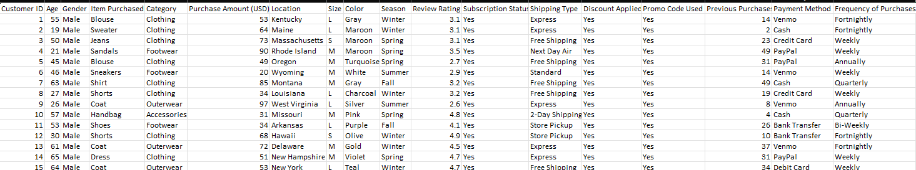

🔍 Data Quality
- Missing values in Review Rating
- Cleaned using median imputation per category

- Data Preparation & Exploratory Analysis (Python)

Data preprocessing was performed using Python:

Key Steps:
- Data loading using pandas
- Handling missing values (Review Rating)
- Column standardization (snake_case)
- Feature engineering:
  - Age groups
  - Purchase frequency
- Removed redundant fields (promo_code_used)
- Loaded cleaned data into MySQL for analysis

- Data Analysis (SQL)

SQL was used to derive business insights:

🔹 Key Analyses Performed

1. Revenue by Gender
- Male customers contribute significantly higher revenue than females

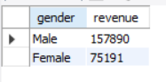

2. High-Spending Discount Users
- Many customers use discounts but still spend above average

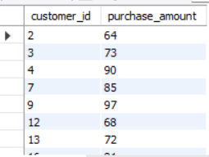
👉 Discounts do not always reduce revenue

3. Top Rated Products
- Products like Gloves, Sandals, Boots have highest ratings

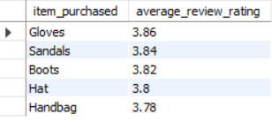

👉 High ratings = strong customer satisfaction

4. Shipping Behavior
- Express shipping users have slightly higher average spending

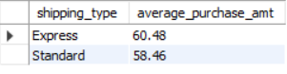

👉 Convenience influences spending

5. Subscription Analysis
- Non-subscribers generate more total revenue
- Average spend is similar for both groups

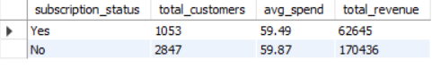

👉 Subscription strategy needs improvement

6. Discount-Driven Products
- Products like Hat, Sneakers, Coat heavily rely on discounts

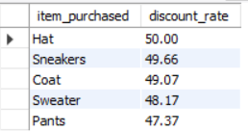

👉 Risk of margin loss

7. Customer Segmentation
- Majority are Loyal customers (3116)

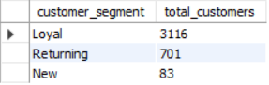

👉 Strong retention base

8. Top Products per Category
- Example:
  - Clothing → Blouse, Pants, Shirt
  - Footwear → Sandals, Shoes, Sneakers

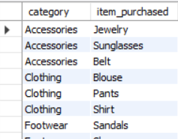

9. Repeat Buyers & Subscription
- Repeat buyers are not strongly linked to subscriptions

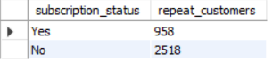

10. Revenue by Age Group
- Young Adults generate highest revenue

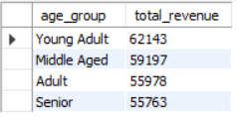

- Dashboard (Power BI)

An interactive dashboard was built to visualize:
- Revenue trends
- Customer segments
- Category performance
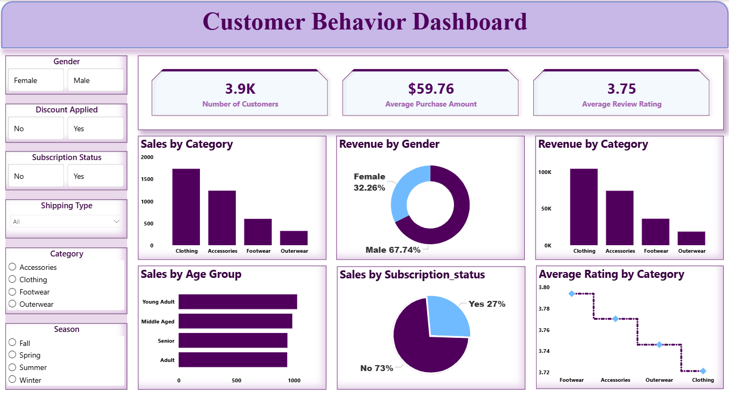
- Subscription insights

👉 KPIs include:
- Total Customers: 3.9K
- Avg Purchase: ~$59.76
- Avg Rating: 3.75
- Key Insights

📌 Customer Behavior
- Loyal customers dominate the dataset
- Young adults are the highest contributors

📌 Product Insights
- Certain products rely heavily on discounts
- Top-rated products are not always top-selling

📌 Revenue Drivers
- Discounts increase volume but may affect margins
- Express shipping correlates with higher spend

📌 Subscription Gap
- Subscriptions are underutilized
- No strong impact on spending

- Business Recommendations

🎯 1. Improve Subscription Strategy
- Offer exclusive benefits (discounts, faster shipping)

🎯 2. Optimize Discount Usage
- Reduce discounts on high-demand products
- Use targeted promotions instead

🎯 3. Focus on High-Value Segments
- Target Young Adults
- Promote loyalty programs

🎯 4. Product Strategy
- Promote high-rated products
- Bundle slow-moving items with popular ones

🎯 5. Marketing Optimization
- Personalize campaigns based on:
  - Category preference
  - Purchase frequency

- Tools & Technologies
- Python (Pandas, Data Cleaning)
- SQL (MySQL – Business Analysis)
- Power BI (Dashboard & Visualization)
- Jupyter Notebook

10. Conclusion

This project demonstrates how data-driven analysis can:
- Identify customer trends
- Improve decision-making
- Optimize business strategies

👉 The insights can directly help improve:
- Revenue
- Customer retention
- Marketing effectiveness

